IB Physics
Forces
Chapter 4 Syllabus
Block |  | In Class: | Due on this class:
1  Oct  23/24 |  | DI-Stupid Teacher Tricks  GW-Force, Net force and weight  DI-More Than One Force | VF 4A - Newton's Laws  VF 4B - Simple F = ma  VF 4C - Mass and Weight
2  Oct  28/29 |  | DI-More Stupid Elevator Tricks  GW-Vertical Acceleration  GW-FA4.2-Vertical Acceleration | VF 4D - More than one force  VF 4E - Vertical Acceleration problems  Turn in FA4.1
3  Oct 30 /Nov 4 |  | SA4.2-Vertical Acceleration (first 30 minutes)  VF-4F Calculating the force of friction  DI-Demos/Solving Friction problems | Turn in FA4.2
3 ¾  Oct 31  /Nov 1 |  | GW-Friction problems  GW-FA4.3 - Friction  DI-Forces on inclined planes (4H) (last 10 minutes) | VF 4F - Force of Friction  VF 4G - Horizontal acceleration with Friction
4  Nov  5/6 |  | Demonstrations involving Magic and Projections of images | Bring a ceramic mug
5  Nov  7/12 |  | SA4.3-Friction (First 30 minutes)  IW-Inclined Planes  GW-Inclined Planes  DI-Force Lab Explained | (VF 4H - forces along an inclined plane)  VF 4I - Inclined Plane Problems  Turn in FA4.3
6  Nov  13/14 |  | GW-Inclined Planes  GW-Force Lab
7  Nov  15/18 |  | SA4.4-Inclined Planes (First 30 minutes)  VF-4J Pulleys  GW Pulleys FA4.5  GW force Lab | VF 4J - Pulleys  Turn in FA4.4  Turn in FA4.5
Nov  19/20 |  | Gravity and circular motion!!!!! | Turn In Force Lab  VF 5A, 5B
 | Assignments  - 1 Lab:  - Student designed lab on force (groups of 2) /40 pts  - 4 Formative/ 3 Summative Assessments:  - 4.2 – Vertical Dynamics  - 4.3 – Friction  - 4.4 – Inclined Planes  - 4.5 – Pulleys (no summative) |  |  | Handouts:  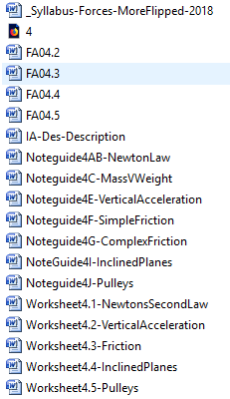 |  | *Handouts:  Syllabus-Forces  FA 4.2/FA 4.3/FA 4.4/FA 4.5  Worksheet-NetForceAndFriction  NoteGuide-InclinedPlanesExample  Worksheet-PlanesAndEquil

