Noteguide for Newton's Laws - Videos 4A, 4B Name

Write down the laws:

1

2

3

F = ma

Example: What force causes a 4.0 kg object to accelerate at 6.0 m/s/s?
(Write down as well the base units of a Newton)

Example: A 2.1 kg hammer accelerates from rest under the influence of a net force of 120 N. What is its final velocity if the force is exerted over a distance of 78 cm

(Whiteboards on the back)
Try these example problems. Don't freak out if you can't immediately get the answer. We will work on these as a group in class. They are solved in the linked videos that follow the main one
1. What unbalanced force causes a 892 g object to accelerate at -9.81 m/s/s? (-8.75 N) | 2. What is the acceleration of a 12 kg object if you exert 37 N of unbalanced force on it? (3.1 m/s/s)
3. What is the mass of an object if when there is a 128 N net force acting on it, it accelerates at  3.7 ms⁻²? (35 kg) | 4. A 16 kg object going 23 ms⁻¹ is stopped by a force in 0.125 s. What force? (-2944 N)
5. A 3.84 kg object going 42.0 ms⁻¹ experiences a force of -23.5 N for 2.60 s. What is the final velocity of the object? (26.1 m/s) | 6. A 143 gram baseball going 39 m/s caught by the catcher. In stopping, the baseball travels 7.5 cm. What is the average force exerted on the ball?  (-1450 N)

Noteguide for Mass vs. Weight - Videos 4C Name

Mass Weight

Example: What is the weight of a 5.0 kg mass on earth?

Try these example problems. Don't freak out if you can't immediately get the answer. We will work on these as a group in class. They are solved in the linked videos that follow the main one
1. What is the weight of a 20.3 gram European Swallow? (0.199 N) | 2. What is the mass of an object that weighs 582 N on earth? (59.3 kg)
3. A 62.0 kg person weighs 101 N on the moon. What is the moon’s “g”? (1.63 N/kg)

Noteguide for Net Force - Videos 4D Name

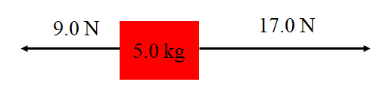
Steps:

1.

2.

3.

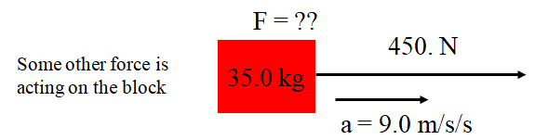

Try these example problems. If you don't get the answer, watch the video to see how.
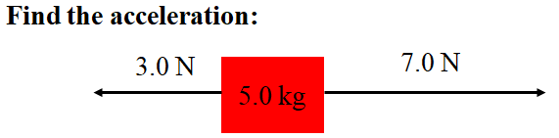(0.80 m/s/s) | 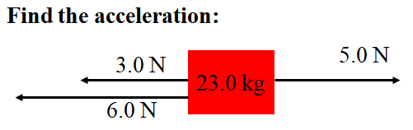(-0.17 m/s/s)
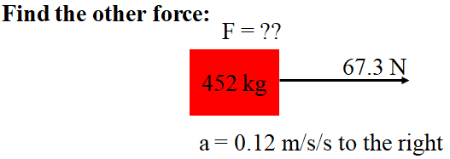(-13 N) | 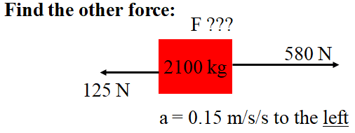(-770 N)

Noteguide for Vertical Acceleration - Videos 4E Name

Example 1

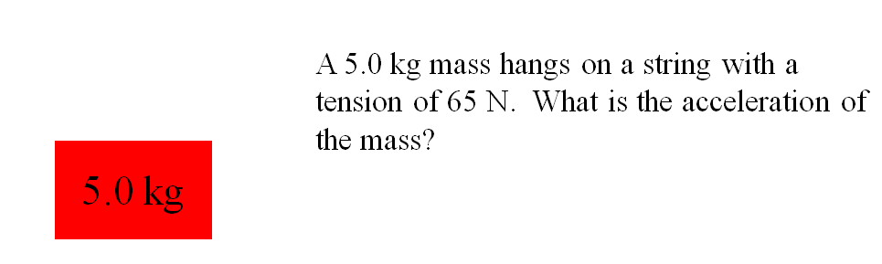

Example 2

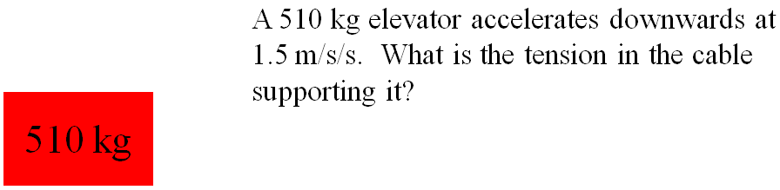

Example 3

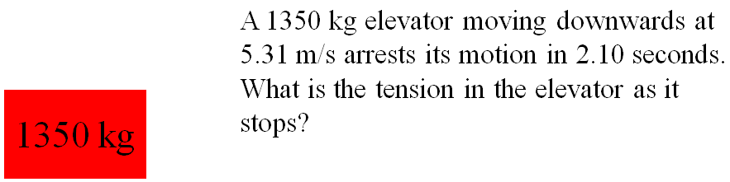

(Do the whiteboards on the back)

Try to do these without looking at the video, but if you get stuck, watch the video until you get unstuck, and do it from there.
1. A 314 kg elevator accelerates upward 4.7 m/s/s. What is the tension in the cable supporting it?  (4556 ≈ 4600 N) | 2. A 314 kg elevator accelerates downward at 2.7 m/s/s. What is the tension in the cable supporting it? (2233 ≈ 2200 N)
3. A 10.0 kg mass hangs on a string with a tension of 126 N, what is its acceleration?  (2.79 ≈ 2.8 m/s/s upwards) | 4. A 10.0 kg mass hangs on a string with a tension of 52.0 N, what is its acceleration?  (-4.61 ≈ 4.6 m/s/s downwards)
5. A 62 kg climber falling at 9.4 m/s has their downward motion arrested in a distance of 5.3 m. What is the tension on the rope if the acceleration is uniform? (1125 ≈ 1100 N) | 6. A 1420 kg elevator is moving upwards at 4.1 m/s and stops in 1.7 s. What is the tension in the cable supporting the elevator as it stops?  (10,505 ≈ 11,000 N)

Friction Noteguide Videos 4F Name
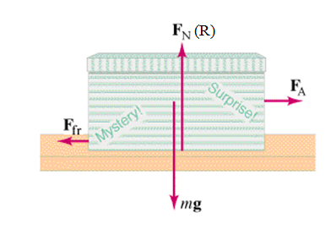
Friction - Force needed to drag one object across another. (At a constant velocity):

Depends on:

Not supposed to depend on:

Table from the book: (IB calls kinetic friction "dynamic")
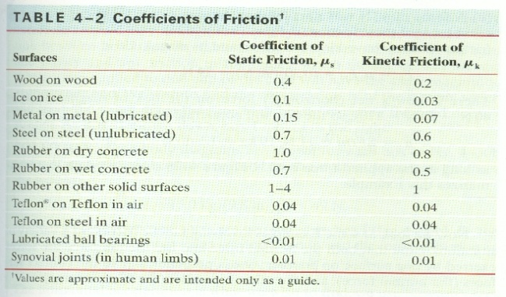

Dynamic Friction - Force needed to keep it going at a constant velocity. (AKA Kinetic friction)
F_{F} = μ_{d}R
Always in opposition to velocity (direction it is sliding)

Static Friction - Force needed to start motion.
F_{F} < μ_{s}R
Keeps the object from moving if it can.
Only relevant when object is stationary.
Always in opposition to applied force.
Calculated value is a maximum

Try these Whiteboards - watch the video if you can't get them.
1. What force is needed to start to slide a 45.0 block of rubber across dry concrete? (441 N ) | 2. What force is needed to continue to slide a 32.0 block of wood across a wood floor? (62.8 N )
3. What force is needed to begin sliding a 921 kg block of ice across a frozen lake?  What force will it then take to keep it sliding? (904 N, 271 N ) | 4. What force is needed to begin sliding a 2350 kg car across wet concrete?  (16,100 N )
5. What is the mass of ice you have if it takes 12.0 N of force to slide it at a constant speed across ice? (40.8 kg ) | 6. You have a 2.1 kg block of plastic and it takes you 8.65 N of force to slide it at a constant speed across your Formica table. What is the coefficient of friction? (0.42 )

Noteguide for Solving Friction Problems Videos 4G Name

Sample Problem: A 5.00 kg block rests on a level table where there is a static coefficient of friction of 0.470, and a dynamic of 0.170.
a) What are the dynamic and maximum static forces of friction? (8.3385 N ≈ 8.34 N, 23.0535 N ≈ 23.1 N)

b) If it is at rest and you exert a force of 12.0 N sideways on it what happens? (draw a diagram, understand)

c) If it is at rest and you exert a force of 35.0 N to the right on it, what is the acceleration of the block? (+5.33 m/s/s)

d) If it is sliding to the right and you exert a force of 7.50 N to the left, what is the acceleration of the block?
(-3.17 m/s/s)

e) If it is sliding to the right, but decelerating at 0.950 m/s/s, what force is acting on the block? (+3.59 N)

f) It is sliding to the right at 7.20 m/s and it slides to a halt in a distance of 12.0 m. What other force besides friction is exerted on the block as it slides to a halt? (-2.46 N)

Noteguide for Inclined Planes Videos 4I Name

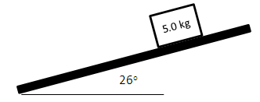
A 5.0 kg object is on an inclined plane that makes an angle of 26º with the horizontal. Make up the plane positive. The coefficient of kinetic friction is 0.35, and static is 0.52
A) What are the components of gravity parallel and perpendicular to the plane? What is the force of kinetic friction, and what is the maximum static friction? Would the block be able to remain at rest on the plane?

B) Were the block to slide down the plane, what would be its acceleration?

C) What force would make the block slide up the plane with an acceleration of 2.4 m/s/s?

D) What force in what direction would make the block slide down the plane with an acceleration of 0.80 m/s/s?

E) Suppose there is an outside force of 9.5 N acting up the plane, what force in what direction would make the block slide down the plane with an acceleration of 1.9 m/s/s down the plane?

Noteguide for Pulleys - Videos 4J Name

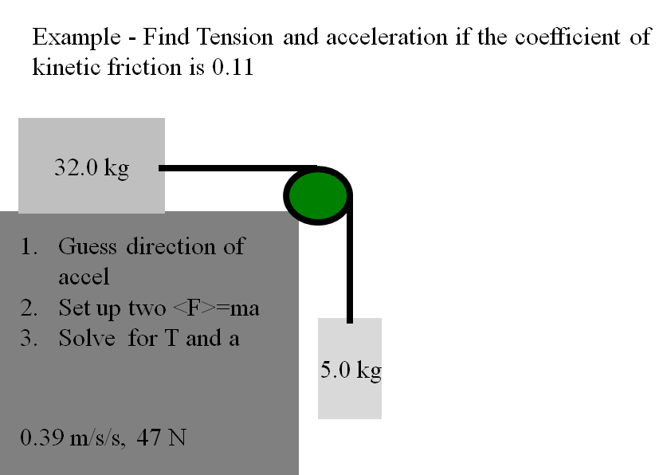

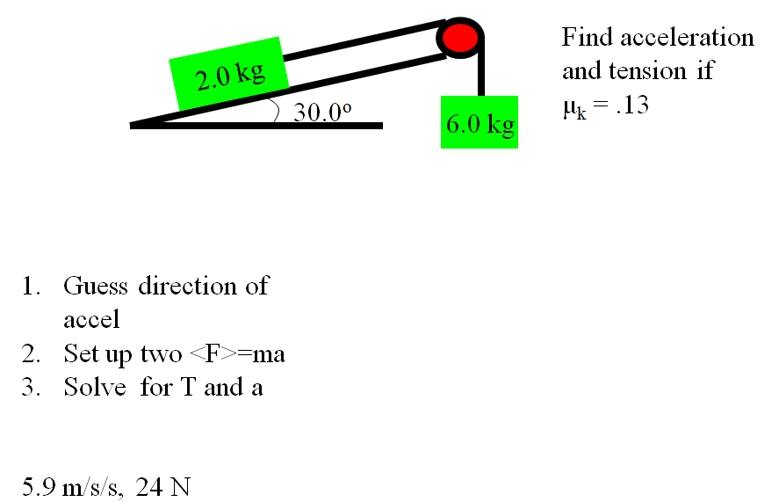

Noteguide for Equilibrium (Video 9A) Name

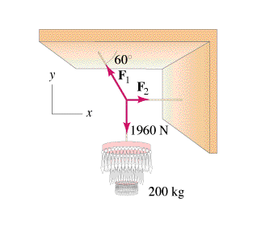

How to solve:
Net force in the x dir. = 0
Net force in the y dir. = 0

Step By Step:
  - Draw Picture with forces as arrows
  - Calculate weights (?)
  - Express/calculate components (SOH CAH TOA)
  - Set up a <sum of all forces> = 0 equation for x and another for the y direction
  - Do math.

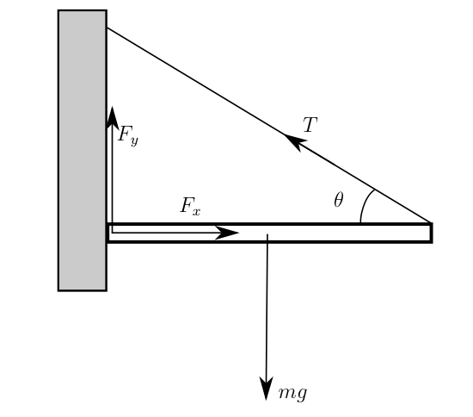

Noteguide for Equilibrant (Videos 9B) Name

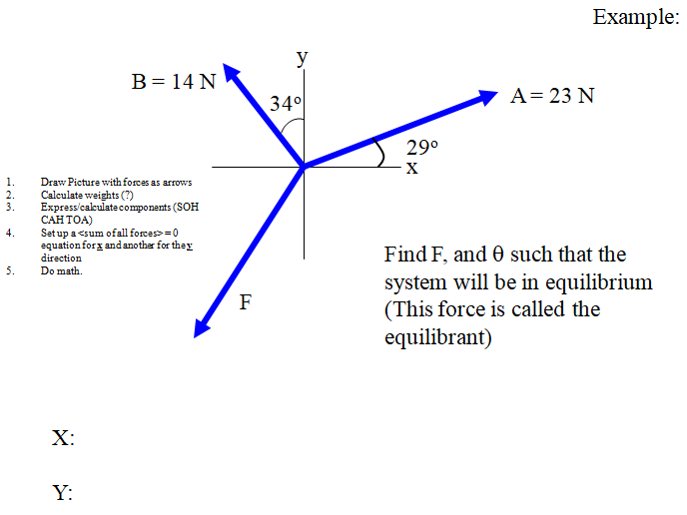

Whiteboard:
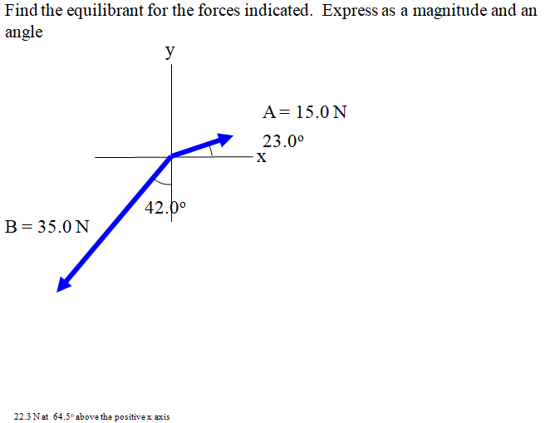

X:

Y:

Noteguide for Translational Equilibrium with Two Unknowns (Videos 9C) Name

- Draw Picture with forces as arrows
- Calculate weights (?)
- Express/calculate components (SOH CAH TOA)
- Set up a <sum of all forces> = 0 equation for x and another for the y direction
- Do math.

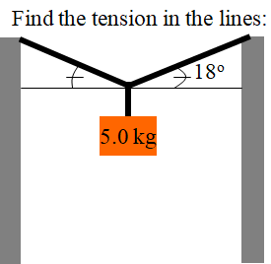

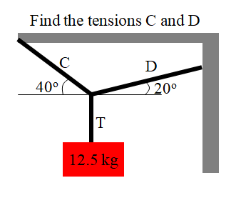

Whiteboards:
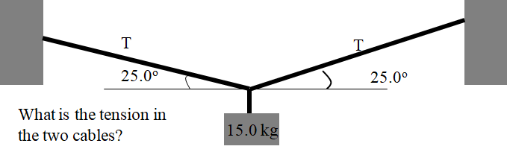 (174 N)

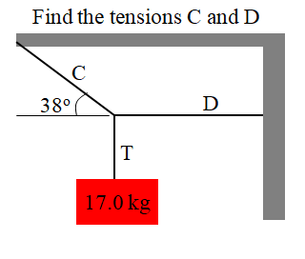(C = 271 N, D = 213 N)

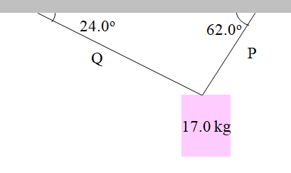(P = 152.7 N, Q = 78.5 N)

