Translational Equilibrium 9.1
1. | Find the third force (the equilibrant) that would prevent the system from accelerating. 23.16 N At 292.8º Trig angle. (22.8º to the right of the -y axis)
2. | Find the third force (the equilibrant) that would prevent the system from accelerating. 6.000 N At 348.9º Trig angle. (11.1º below the +x axis)
3.  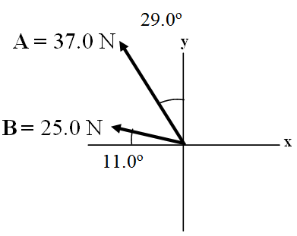 | Find the third force (the equilibrant) that would prevent the system from accelerating. 56.4 N @ 318.8º Trig angle. (41.2º below the +x axis)
4. | Cable A makes an angle of 63.0º with the horizontal, and B makes an angle of 23.0º with the horizontal. What is the tension in each cable for there to be no acceleration of the system?  A = 606 N  B = 299 N
5. 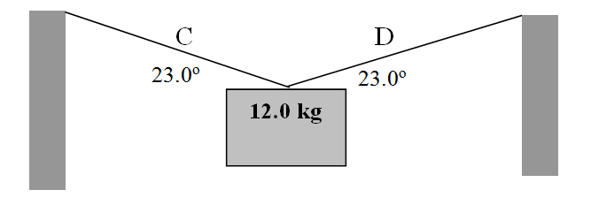 | Find the tensions in Cable C and D:  C = 151 N  D = 151 N

6.  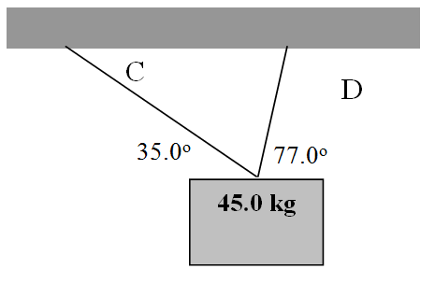 | Find the tensions in Cable C and D:  C = 107 N  D = 390. N
7.  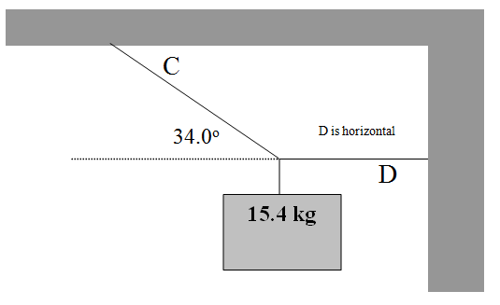 | Find the tensions in Cable C and D:  C = 270. N  D = 224 N
8.  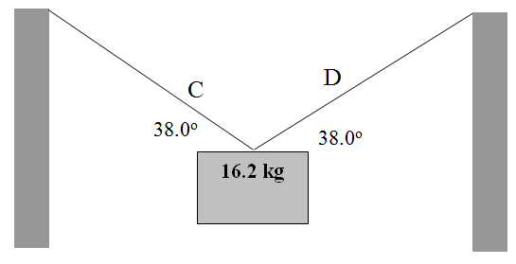 | Find the tensions in Cable C and D:  C = 129 N  D = 129 N
9.  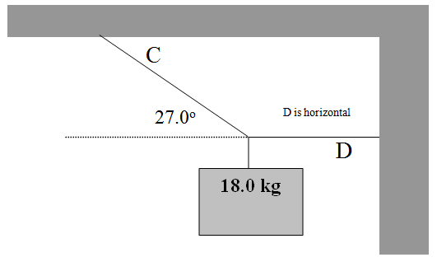 | Find the tensions in Cable C and D:  C = 389 N  D = 347 N
10. | Cable A has a force of 23 N along it, what must be the tensions in cable C and B for there to be no acceleration of the system?  B = 17 N  C = 27 N
Also from your textbook: Chapter 9: 1, 5, 9, 11, 12, 14 starting p. 247

