Friction Noteguide Videos 4F Name
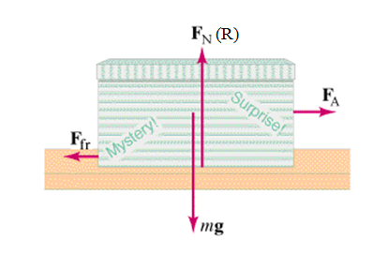
Friction - Force needed to drag one object across another. (At a constant velocity):

Depends on:

Not supposed to depend on:

Table from the book: (IB calls kinetic friction "dynamic")
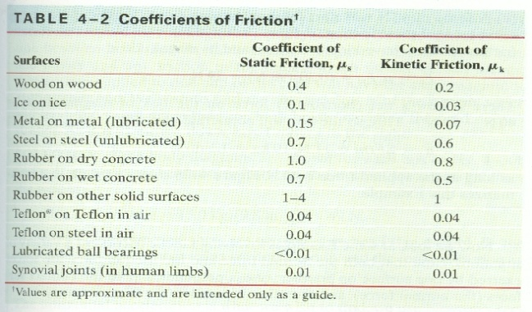

Dynamic Friction - Force needed to keep it going at a constant velocity. (AKA Kinetic friction)
F_{F} = μ_{d}R
Always in opposition to velocity (direction it is sliding)

Static Friction - Force needed to start motion.
F_{F} < μ_{s}R
Keeps the object from moving if it can.
Only relevant when object is stationary.
Always in opposition to applied force.
Calculated value is a maximum

Try these Whiteboards - watch the video if you can't get them.
1. What force is needed to start to slide a 45.0 block of rubber across dry concrete? (441 N ) | 2. What force is needed to continue to slide a 32.0 block of wood across a wood floor? (62.8 N )
3. What force is needed to begin sliding a 921 kg block of ice across a frozen lake?  What force will it then take to keep it sliding? (904 N, 271 N ) | 4. What force is needed to begin sliding a 2350 kg car across wet concrete?  (16,100 N )
5. What is the mass of ice you have if it takes 12.0 N of force to slide it at a constant speed across ice? (40.8 kg ) | 6. You have a 2.1 kg block of plastic and it takes you 8.65 N of force to slide it at a constant speed across your Formica table. What is the coefficient of friction? (0.42 )

