Noteguide for Types of vectors - Videos 3A Name

Make a guess, then watch the video:

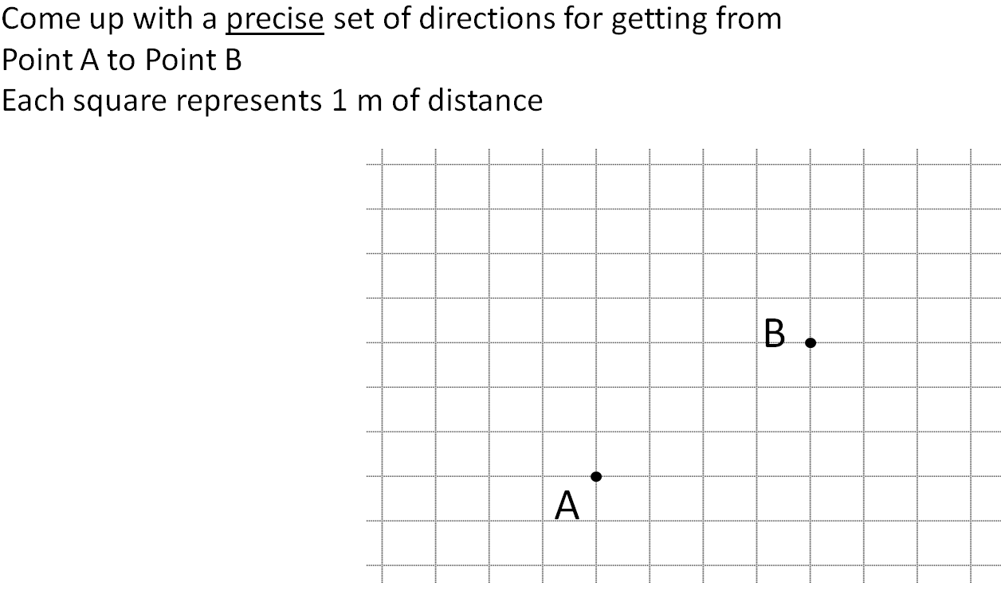

Write these directions:
Vector Component:

Angle Magnitude:

Noteguide for Finding Vector Components - Videos 3B Name

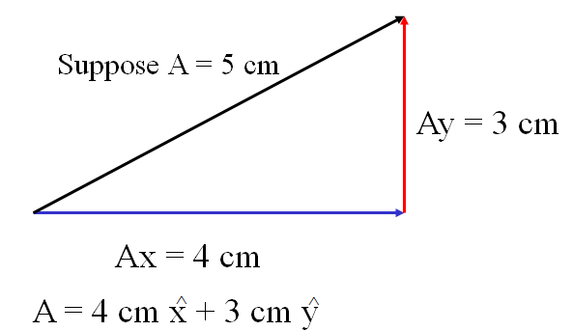

Try to write these AM vectors as Component Vectors. Decide which side is x and which is y, which are negative, which are positive. Write it like I showed you in the previous part. Watch the videos to check your answers.
1. 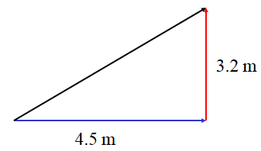 | 2. 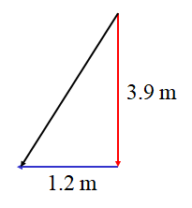
3. 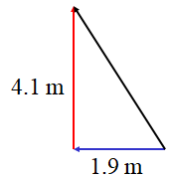 | (Draw a cartoon here)

Finding the lengths of the sides
(Get your calculator out and calculate the things I do)
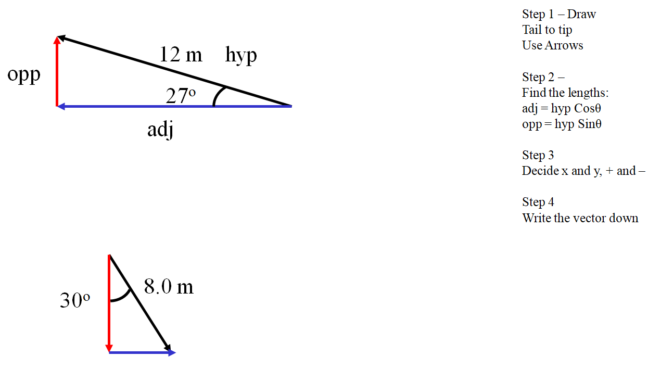

Try this one yourself:

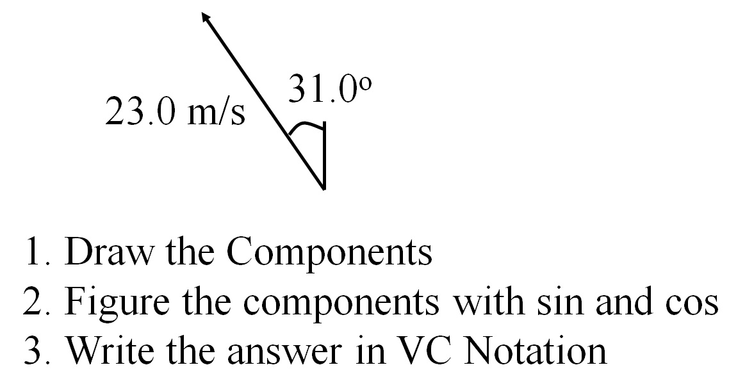

-11.8 m/s x + 19.7 m/s y (the x and the y should have little ^ hats on them ; - )

Noteguide for Adding VC vectors - Videos 3C Name

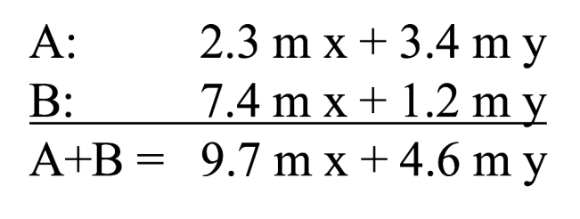

Try these example problems. Don't freak out if you can't immediately get the answer. We will work on these as a group in class. They are solved in the linked videos that follow the main one
1. 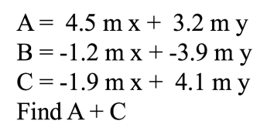(2.6 m x + 7.3 m y) | 2. 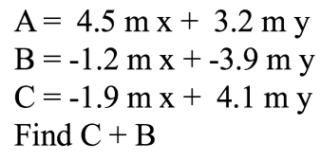(-3.1 m x + 0.2 m y)
3. 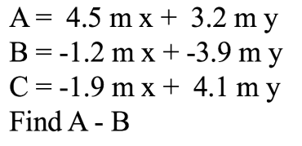(5.7 m x + 7.1 m y) | 4. 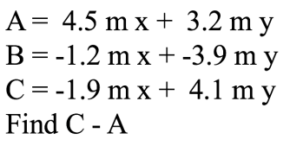(-6.4 m x + 0.9 m y)

Noteguide for Vector Component to Angle Magnitude - Videos 3D Name

Write down step by step directions:

Given this VC Vector: 5.10 m x + -1.70 m y Draw the AM vector

Try these example problems. Don't freak out if you can't immediately get the answer. We will work on these as a group in class. They are solved in the linked videos that follow the main one. Answers to these are on the back of this sheet. Be sure you can make the drawings correctly with the arrows in the right direction.
1. Draw this vector, and find its magnitude and the angle it forms with the x-axis:  3.4 m x + 2.0 m y | 2. Draw this vector, and find its magnitude and the angle it forms with the x-axis:  -22 m/s x + 15 m/s y
3. Draw this vector, and find its magnitude and the angle it forms with the x-axis:  9.00 N x + -15.0 N y | 4. Draw this vector, and find its magnitude and the angle it forms with the x-axis:  15.00 m/s/s x + -9.80 m/s/s y

Answers to whiteboards – be sure you have drawn the arrows the right way. Don’t worry if the videos do something with a trig angle – that is not a thing anymore

1. 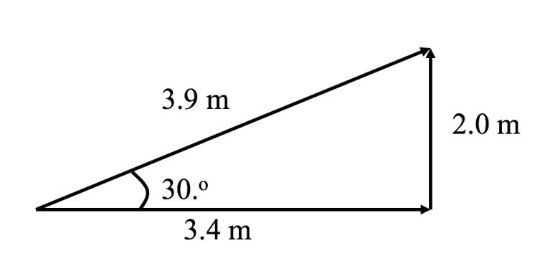 | 2. 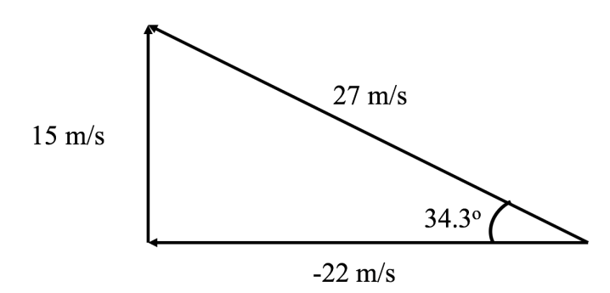
3. 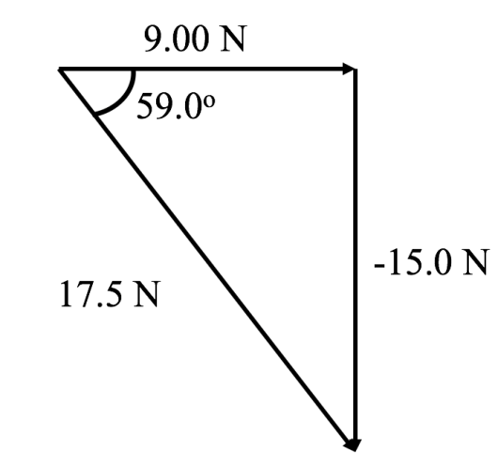 | 4. 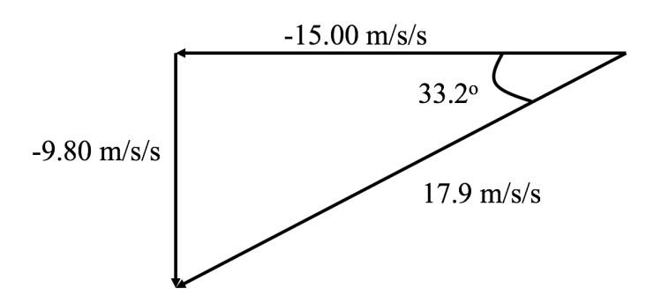

Noteguide for Adding two AM vectors - Videos 3E Name

Write down the steps for this:

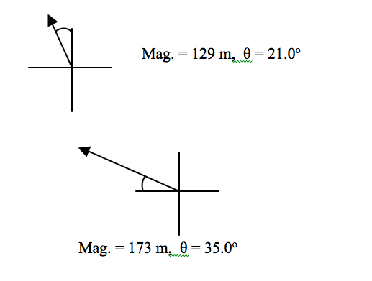

A

B

Noteguide for Cliff Problems - Videos 3F Name

Red Elk runs off a 3.8 m tall cliff with a horizontal velocity of 4.2 m/s, and does a faceplant in a snow drift.
a. What time is he in the air?
b. How far out does he land?
c. What is his velocity of impact with the snow drift?

Noteguide for Cliff Problems - Videos 3G Name

Red Elk throws a ball with a purely horizontal velocity from the roof of a building that is 21 m tall. The ball lands 17 m from the base of the building.
a) What time is the ball in the air?
b) What is the velocity of impact in terms of an angle and a magnitude?

H | V
s  u  v  a  t | s  u  v  a  t

c) What is the velocity and position of the ball at exactly 1.1 seconds from its release?

d) What is the velocity and position of the ball at an elevation of 10.0 m from the ground?

Noteguide for Arc Problems - Videos 3H Name

Red Elk hits a golf ball at a speed of 41.3 m/s at an angle of 78.2º above the horizontal. Assume that the ground is level, and ignore air friction.
a) What time is the ball in the air?
b) What is the horizontal distance that the ball goes before striking the ground?
c) What is the speed at the highest point on the ball's trajectory, and what is the greatest height?

d) What is the velocity and position of the ball at exactly 5.00 seconds from its launch?

e) What is the velocity and position of the ball at an elevation of 60.0 m from the ground on the way down?

Noteguide for Range Equation - Videos 3I Name

Solve for θ:

How to find angle to hit 90.0 m:

How to find angle hit 200. m:

Noteguide for Boat Crossing River - Videos 3J Name

