Noteguide for Adding two AM vectors - Videos 3E Name

Write down the steps for this:

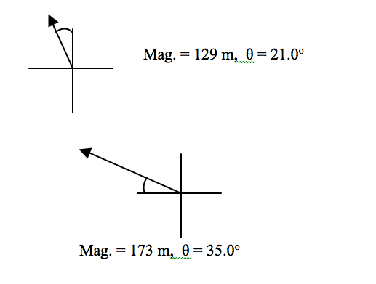

A

B

