Noteguide for Adding VC vectors - Videos 3C Name

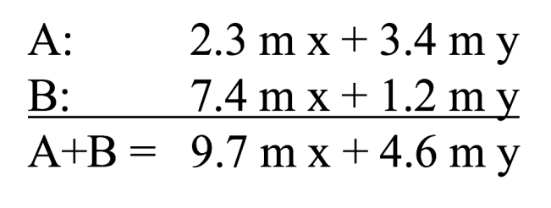

Try these example problems. Don't freak out if you can't immediately get the answer. We will work on these as a group in class. They are solved in the linked videos that follow the main one
1. 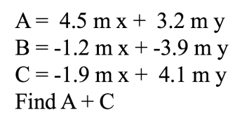(2.6 m x + 7.3 m y) | 2. 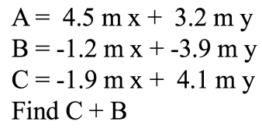(-3.1 m x + 0.2 m y)
3. 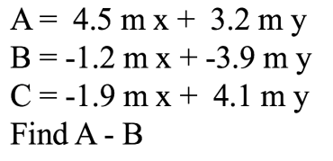(5.7 m x + 7.1 m y) | 4. 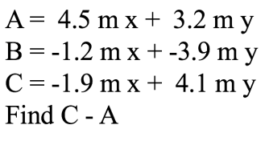(-6.4 m x + 0.9 m y)

