Noteguide for Adding VC vectors - Videos 3AB Name

A. Come up with a precise set of directions for getting from Point A to Point B. Each square represents 1 m of distance

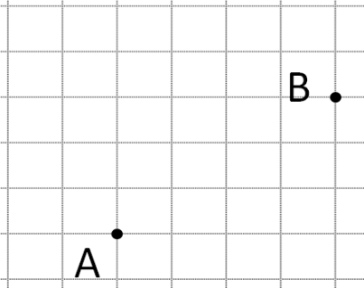
Two Ways:

B. Vector Components:
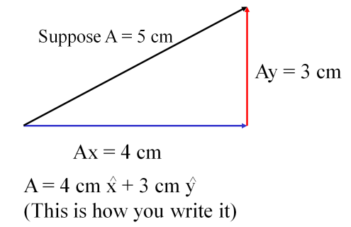

Example:
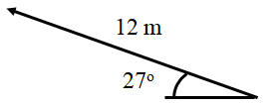

Step 1:

Step 2:

Step 3:

Try these example problems. Don't freak out if you can't immediately get the answer. We will work on these as a group in class. They are solved in the linked videos that follow the main one
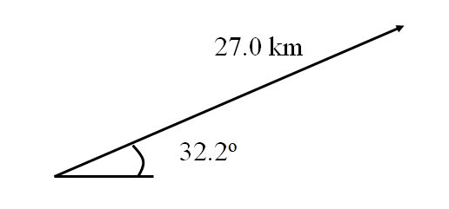  1. 22.8 km x + 14.4 km y | 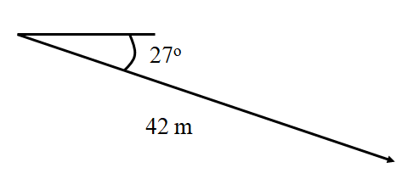  2. 37 m x + -19 m y
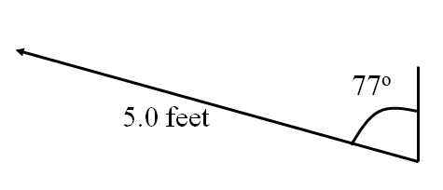  3. -4.9 ft x + 1.1 ft y | 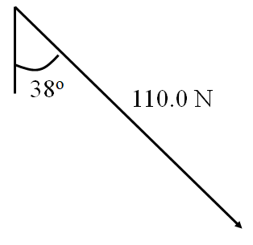  4. 68 N x + -87 N y

