**Noteguide for Range Equation - Videos 3I Name**



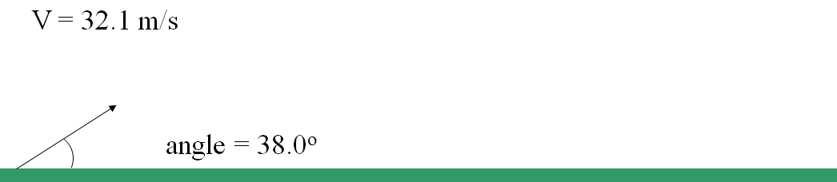

Solve for θ:

How to find angle to hit 90.0 m:

How to find angle hit 200. m: