Name
Graphs of Motion - Answer the questions below it, and show any calculations you made. Don’t freak out if you don’t get my exact answer – you should be within 0.1 or 0.2 of the right answer.
1. The position of a car is shown on the graph below. Answer the questions below it, and show any calculations you made.
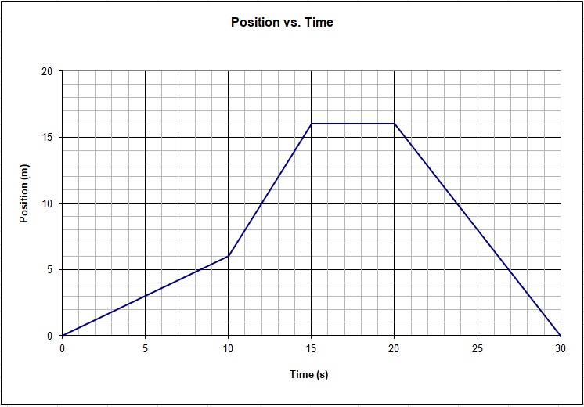
This is a position question – you can just read the graph
a) What is the car’s position at 15 seconds? 25 seconds? How about 6 s? 26 s?

b) At what time(s) is the car at 8 m? 16 m? 5 m?

The next few questions are about velocity. Velocity is slope on this kind of graph.
c) What is the velocity at 5 seconds? (Use the whole line segment to find the slope – from 0 – 10 s)

d) What is the velocity at 12 seconds? at 17 seconds? At 25 seconds? (Use the whole line segment)

Answers: (a: 16 m, 8 m, ≈3.6 m, ≈6.3 m) (b: 11 s and 25 s, 15 s-20 s, 8.3 s and 26.9 s) (c: 0.60 m/s) (d: 2.0 m/s, 0.0 m/s, -1.6 m/s)
2. – This is a velocity vs. time graph for a different car.
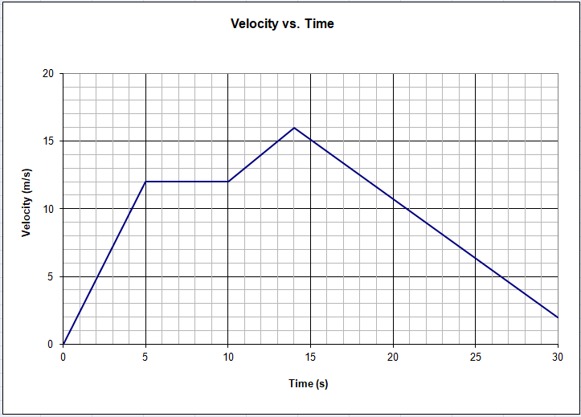
This is a velocity question – you can just read the graph.
a) When is the velocity 12 m/s? What is the highest velocity it has? What is the velocity at 20.0 s?

The next question is an acceleration question. Acceleration is the slope of a velocity graph.
b) What is the acceleration at 3 seconds? at 6 seconds? at 12 seconds? at 25 seconds? Use the whole line segment to calculate the slopes.

These are displacement questions. Displacement is the area under this kind of graph.
c) What is the displacement of the car between 5 and 10 seconds?

d) What is the displacement of the car between 0 and 5 seconds?

e) What is the displacement for the whole graph? (0-30 s)

Answers: (a 5-10s and 18.6s, 16 m/s, 10.8 m/s) (b 2.4 m/s/s, 0, 1 m/s/s, -0.875 m/s/s) (c 60 m) (2d 30 m) (e 290 m)

