IB Physics Labs

Design:
- Defining the Problem and Selecting Variables –
  - State a focused problem: “The question to answer is how the time of six bounces is related to the height of dropping it.” would be a good example, if you explained a bit first that you were talking about a bouncing ball. IB no longer requires that you make a hypothesis, but you can if you want.
  - Variables need to be explicitly listed as either dependent (measured), independent (manipulated) or controlled (constant). in the case of the bouncing ball, the dependent variable would be time, the independent, height, and controlled would be the ball and the surface on which you are dropping the ball
- Controlling the variables
- third aspect

Investigating the relationship between the drop height and time
of 6 bounces of a super-ball.

INTRODUCTION

In this laboratory I’m going to relate the time that a ball needs for 6 bounces from different dropping heights.
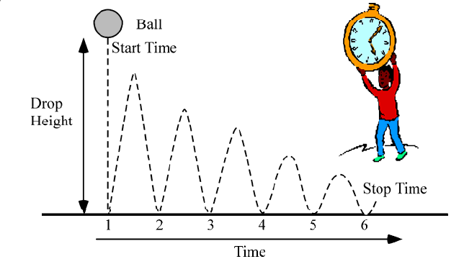
My variables are height, time for bounces, mass of ball, bouncing surface and number of bounces. The independent variable is the dropping height H because I choose it. The dependent variable is the bouncing time T because this depends on the drop height. The constants must be the mass of ball, bouncing surface, and number of bounces because they are going to be the same during the whole experiment.
The question to answer is how the time of six bounces is related to the height of dropping it. I will look for a linear and proportional relationship between the independent and dependent variables. My idea is if the height increases, the time will increase. If I don’t find this result I will graph whatever is needed to find the relationship.
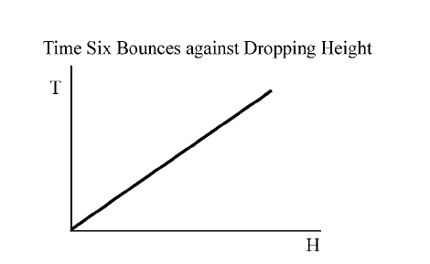
Therefore the function of this graph would be T = mH where T is time, m is the gradient, and H is the height.
DESIGN
The method to make this experiment is easy and simple. The equipment and materials that I will use are: one ball, a stopwatch, a meter stick, the floor surface, a table, and materials to write. When I have all of this, I will start the measure of the independent variable. I’ll use a paw of a table and there I’ll mark lightly different heights with the ruler. I’ll start with 20 and then 30, 40, 50, 60 and I’ll use the height of the table and the ruler too.
To make the experiment I will put the ruler horizontally to the mark in the table and in the edge of the rule I will put the ball. Then I’ll leave the ball fall, therefore now I’m going to explain how I will measure the time (dependent variable). When the ball is on the ruler I’ll be ready with the watch in my hand. I’ll leave the ball go from the ruler and I will press the button on the stopwatch at this moment in order to start timing. I will then watch and listen for the ball to make 6 bounces. At the moment
of the 6th bounce I will stop the stopwatch timing. Also I should explain how I’m going to keep the constant variable. The surface that I’ll choose it’ll be the ground of the classroom and the ball will be a showy ball and therefore I will not miss the ball.
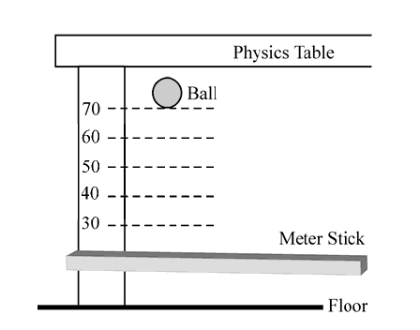
Another point to talk about is how many times I’ll measure the variables. I will measure the time for six bounces 4 times for each different height and then I’ll take the average. To measure the height I’ll repeat it 3 times and I’ll take the average. I’m going to take 7 different values from 20 cm being the smallest height until 100 cm being the longest height.
Data Collection and Processing:
- first aspect
- second aspect
- third aspect

Conclusion and Evaluation:
- first aspect
- second aspect
- third aspect

