**Significant Figures** (sig figs)

1. The leftmost nonzero digit is the most significant digit

2. If there is no decimal point, the rightmost nonzero digit is the least significant digit

3. If there is a decimal point, the rightmost digit is the least significant digit even if it is a zero.

4. All digits between the least and most are also significant.

|  |  |
| --- | --- |
| 3010  3010.00  20  20.  20.0  30.010  3.200x104 | 100  1.0x102  100.  0.012  0.000150  37 people in a class  50,000 at a rally |

In college you will learn some rules about propagating sig figs when you do calculations, but for now let's round our answers to the operand with the **fewest** sig figs.

**Noteguide for Uncertainty - Videos 1B, 1C, 1D, and 1E Name**

**1B - What uncertainty is and what it means:**

For the value **10 ± 2** We think the value is 10 , but it could be as big as and as small as

The absolute uncertainty is and the fractional uncertainty is or %

The rule for estimating uncertainty when measuring something on an analog scale: (like a ruler)

The rule for estimating the uncertainty of a digital meter:

The rule for finding the uncertainty of a collection of repeated measurements:

**Propagation of Uncertainty:** (How to find the uncertainty of a calculation)

**1C - Adding or subtracting the rule is:**

Examples

(7.6 ± .4)

- (2.5 ± .3)

(2.3 ± .1)

+ (3.6 ± .3)

See if you can get these - they are solved in the example problem videos that follow the main video:

(45 ± 3) + (12 ± 2) = ??

(12.1 ± 0.3) - (4.5 ± 0.6) = ??

(11 ± 3) - (7 ± 2) = ??

Answers: 57 ± 5, 7.6 ± 0.9, 4 ± 5

**1D - Multiplying or dividing the rule is:**

**With percents: (first video)**

(5 ± 10%)

x (20 ± 15%)

**With absolute uncertainty: (second video) (Write the weird math expression here)**

Example: A metal plate measures 21.1 + 0.5 cm by 15.3 + 0.1 cm. What is its area?

Step 1 -

Step 2 -

Try these examples: (Again - solved on the website)

|  |  |
| --- | --- |
| (45 ± 1) x (12 ± 1) = ??  540. ± 57 | (30.0 ± .7) / (1.2 ± .1) = ??  25 ± 2.7 |

**1E - The rule for powers: (Write the math expression here)**

Example: A cube measures 2.52 ± 0.05 cm on a side. What is its volume in cc?

Step 1 -

Step 2 -

Try these examples:

|  |  |
| --- | --- |
| (4.5 ± 1.0)2 = ??  20.3 ± 9.0 | 5.000 ± 0.020?? |

**Noteguide for Acceleration - Videos 2C Name**

**2C - Acceleration** (first video - Acceleration Intro)

Write down what these quantities are:

Quantity Formula Units What it is called

|  |  |  |  |
| --- | --- | --- | --- |
| v |  |  |  |
| a |  |  |  |

Example: A car goes from 0 to 27 m/s in 9.0 seconds, what is its acceleration?

Super Confusing Example: A rocket accelerates at 4.5 “g” s. What time will it take to reach the speed of sound (Mach I = 343 m/s) from rest?

Try these example problems. Don't freak out if you can't immediately get the answer. They are solved in the linked videos that follow the main one, so if you get stuck, watch the video.

|  |  |
| --- | --- |
| 1. A car speeds up from 0 to 21 m/s in 5.3 seconds. What is their acceleration? (4.0 m/s/s) | 2. A train can accelerate at 0.15 m/s/s. What time will it take to reach its top speed of 24 m/s from rest? (160 s) |
| 3. What is the final speed if a person accelerates from rest at 32 f/s/s for 2.7 seconds? (86 f/s) | 4. What is your acceleration if your velocity goes from 35 m/s to 20. m/s in 4.7 seconds? (-3.2 m/s/s - hint - what is the change in velocity?) |
| 5. What is your final velocity if you are going 12 m/s and you accelerate at 0.48 m/s/s for the next 16 seconds? (19.68 m/s ≈ 20. m/s - hint - you are already going 12 m/s - figure out the change in velocity with the formula, and add it to 12 m/s) | |

**2C - Velocity and acceleration**  (the second video - Velocity and Acceleration)

Consider the last example problem:

What is your final velocity if you are going 12 m/s and you accelerate at 0.48 m/s/s for the next 16 seconds?

New Formula:

**v = u + at**

Write down what these are:

**v =**

**u =**

**a =**

**t =**

Try these examples:

|  |  |
| --- | --- |
| 1. A car going 24.8 m/s decelerates at -2.451 m/s/s for 1.67 s. What is its final velocity? (20.7 m/s) | 2. What is the acceleration of a ball that goes from 12.5 m/s to 17.8 m/s in 2.5 seconds? (2.1 m/s/s) |
| 3. A cop clocks a car going 22.4 m/s after having accelerated at -7.45 m/s/s for the last 3.4 seconds. What was the initial velocity of the car? (48 m/s) | 4. What time will it take a train to slow from 23.2 m/s to 14.8 m/s if the acceleration is -1.2 m/s/s?  (7.0 s) |

In the unused space below, draw a cartoon of Principal Dellerba chasing Spaceman Spiff through an asteroid belt:

**Noteguide for Kinematics - Videos 2D Name**

**2D - Kinematics** (We call these suvat problems - you'll figure out why ; - )

|  |  |
| --- | --- |
| v = u + at (memorize)  s = (u + v)t  2  v2 = u2 + 2as  s = ut + ½at2 | s - displacement (m)  u - initial velocity (m/s)  v - final velocity (m/s)  a - acceleration (m/s/s)  t - time (s) |

(write down the names I give them, like "No s", "No a" etc.)

Example 1: A car goes from 14 m/s to 26 m/s in 300. m.

* What is the acceleration, and
* What time does it take?

Example 2: A rocket going 3130 m/s accelerates at 0.00135 m/s/s for a distance of 5.50 x 109 m.

* What time does it take, and
* What is the final velocity?

Try these example problems.

|  |  |
| --- | --- |
| 1. A cart stops in a distance of 3.81 m in a time of 4.51 s. What was its initial velocity? (1.69 m/s) | 2. A car going 12 m/s accelerates at 1.2 m/s/s for 5.0 seconds. What is its displacement during this time? (75 m) |
| 3. Another car with a velocity of 27 m/s stops in a distance of 36.74 m. What was its acceleration?  (-9.9 m/s/s) | 4. A car’s brakes slow it at 9.5 m/s/s. If it stops in 47.3 m, how fast was it going to start with? (30. m/s) |
| 5. What time will it take a car going 23 m/s to start with, and accelerating at 3.5 m/s/s, to go 450 m?  (10.7585 ≈ 11 s Hint - it is quadratic with "No v" but you can use "No t" to find v, and then use "No s" to find t without using the quadratic equation) | |

**Noteguide for Displacement Graphs - Videos 2F Name**

Slope on a position time graph:

Whiteboards:

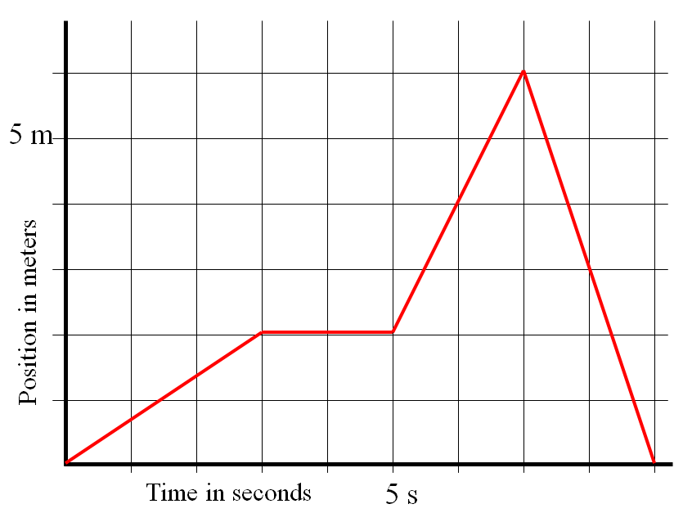

Keep in mind that when you find the slope, you should use the entire line segment. (i.e. 2.0 seconds, use the entire line from t = 0 to t = 3.0 s, and find the rise/run for that entire segment.)

|  |  |
| --- | --- |
| 1. What is the velocity at 2.0 s? (0.67 m/s) | 2. What is the velocity at 4.0 s? (0 m/s) |
| 3. What is the velocity at 6.2 s? (2.0 m/s) | 4. What is the velocity at 8.15 s? (-3.0 m/s) |

**Noteguide for Velocity Graphs - Videos 2G Name**

**Slope of velocity graphs:**

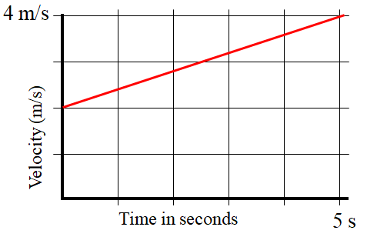

What does the slope on a velocity graph mean?

Whiteboards:

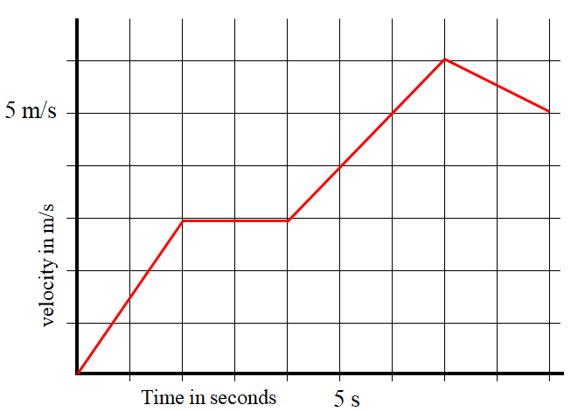

Keep in mind that when you find the slope, you should use the entire line segment.

|  |  |
| --- | --- |
| 1. What is the Acceleration at 1.15887 seconds? (1.5 m/s/s) | 2. What is the Acceleration at 8.1 s? (-0.50 m/s/s) |

(In calculus the slope is the derivative)

**Area under velocity graphs:**



What does the area under a velocity graph mean?

Whiteboards:



"Area under" means the area between the graph and the x-axis. The units of this "area" are meters in this case, so it's not area in a strict sense. Graph areas can have all kinds of different units.

|  |  |
| --- | --- |
| 1. What displacement between 2 and 4 seconds? (6.0 m) | 2. What displacement between 4 and 7 seconds? (13.5 m) |

(In calculus the area under is the integral)

**Noteguide for Free Fall - Videos 2H Name**

Problem Solving Tips

1 - Iff start and stop at same elevation

5 -

2 -

6 -

3 -

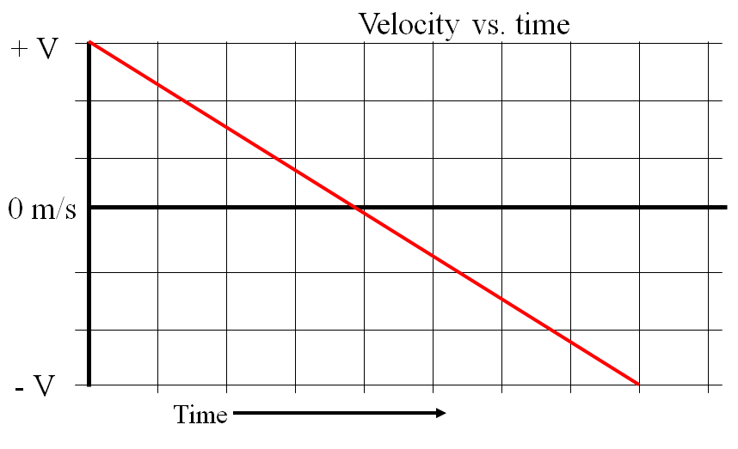

Example 1 - An object is launched straight up with a velocity of +33.0 m/s, and strikes the ground at the same elevation from which it is launched. Use the acceleration of gravity to be -9.81 m/s/s, and neglect air friction

1. When is it at the top?
2. How high does it go at the highest?
3. What total time is it in the air?
4. What is its velocity at an elevation of 45 m? At what times after launch does it reach this elevation?
5. What is its velocity and displacement at 5.20 s after launch?

Example 2 - A piece falls off a rocket that is 27.0 m above the ground when the rocket is moving upwards at 21.0 m/s. Neglect air friction.

1. Describe to your neighbor what the piece will do
2. To what height does the piece rise above its release point before coming down?
3. What is the velocity of impact of the piece with the ground?
4. What time does the piece take to reach the ground?