Request for Media

Indicate what you want a picture or video of

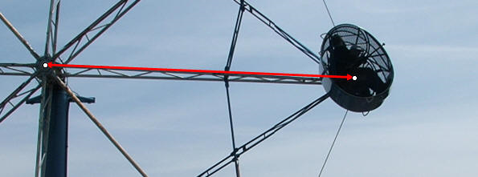

Request for Accelerometer Data

A Physics II student will ride the ride and gather the data for you. There are three orientations you can request:
- Vertical – positive is vertically upward for the rider
- Lateral – positive is horizontally to the right
- Axial – positive is straight ahead

All of these are with respect to the rider relative to them, not in an absolute frame of reference. (i.e. if you request vertical for the Looping Thunder, the accelerometer will be pointing straight down at the top of the loop because the rider will be upside down.)

Request for Direct Measurement

A team Physics II students will directly measure anything the ride operators allow them to. Check on the “Video and Data” site to make sure what you are looking for isn’t already measured. Draw a picture of what you want measured.

