Oaks Park 2019
This assignment is like a final lab practical for this class. You are to complete a group research project and present it to the rest of the class. The presentation should be slides and will be presented to the class. Your peers and I will grade it. You will be working in groups of 3-4 – but we need to make sure that no class has more than 8 or so presentations, so we may have to adjust if there are more than 32 people in a class.
We will gather our data at Oaks Park – and we will spend time the week of the Oaks Park field trip planning our data acquisition. As a class, we will try to gather data on all the rides, and as a group you need to investigate in some depth 3 rides. For the 3 rides your group chooses - you must choose:
1 Vertical Circle ride,
1 Linear Acceleration ride, and
1 Energy or Wildcard ride.

The Rides
Vertical Circle:  Ferris Wheel - Easy  Rock-O-Plane - Easy  Zero-G - Moderate  Scream-N-Eagle - Challenging | Linear Acceleration:  Frog Hopper - Easy vertical  Drop Tower - Easy vertical  Spider - Challenging vertical  Scrambler - Challenging horizontal | Energy Rides:  Big Pink Slide - Easy  Adrenaline Peak - Moderate
Wildcard
Herschell-Spillman Carrousel - Easy
Disk 'O - Challenging
Rock & Roll - Challenging
Go-Karts - Challenging
Bumper Cars - Challenging
Any ride with a unique analysis of your own.

Software: At least one member of your group needs to purchase and download the app "Sensor Kinetics Pro" which costs $0.99 for iOS, and $2.99 for Android. (The Android app has recently been updated, and is more sophisticated) This software lets you use your smartphone as an accelerometer, and share the data in metric units, which is what we need. I think it would be a good idea to have more than one smartphone with the app on it.

Your goal in the presentation is to compare the acceleration data from Sensor Kinetics Pro to calculations of the acceleration using either centripetal acceleration formulas, or video analysis on LoggerPro on one of the PCs of Macs we have. You should be able to interpret your graph and be able to compare the graph data you have from your Smartphone to your calculations. I have help videos to help you with this if you need them.
For each ride you could have literally three slides - Photos/Background, Calculations, and Graphs. Do not read words off the slides to us, rather put notes to yourself on notecards, and practice what you are going to say. Plan for your whole group to take about 10 minutes total for all three rides.
Take photos of the ride for your presentation, (Preferably of a team member on the ride!) and have a team member research the ride. For the calculations slides, I think the easiest thing is to write the calculations neatly on paper, and take a photo. (unless you want to figure out the equations editor in Docs or Word) Show the formula you are using, list the quantities you are plugging in, and then show numbers in that formula. For the Linear Acceleration or Energy ride calculation slide put a screen shot of your video analysis with your formula visible.
For the graphs we will use the Chromebook app called Graphical Analysis. (You can use Sheets if you are more comfortable with that.)

Required slides:
Vertical Circle ride:  - Background info/Photos  - Calculations of centripetal acceleration  - Graph of data. | Linear Acceleration ride:  - Background info/Photos  - Screenshot of Video Analysis with your formula showing  - Graph of data. | Wildcard ride:  - Background info/Photos  - What your investigation is  - What your results are
Energy ride:
- Background info/Photos
- Calculations of the velocity at different points
- Screenshots of the video analysis at those points with your formula showing

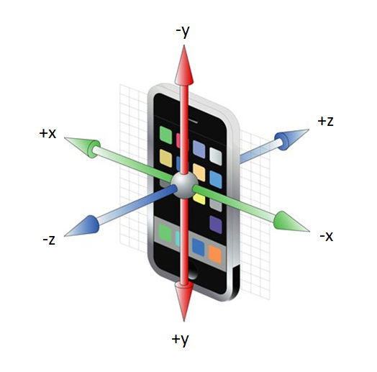
Using Sensor Kinetics Pro:
- Run the app, drag the Accelerometer Sensor "Set Rate" to 50 Hz - this will collect 50 points a second. Click on "Accelerometer Sensor". It will default to "X, Y, Z" mode, which is what you want. Press "Start" to begin collecting data. If you press the "Legend" link it will briefly show you which axis is which color graph. From the accelerometer, click the upper right corner where the down arrow is, and choose "Filters & Settings...". At the bottom, click "LowPass". I think it defaults to 5.0 Hz which works. Try this - it smoothes out the data.
- Try accelerating in each of the three directions indicated by the diagram to the right. Practice interpreting the graph you see on the screen.
- Press "Stop" when you are done collecting data, either hit "Clear" to get rid of the data, or hit the down arrow on the top right, choose "Files and sharing", click "Save...", type a name. Then click on that file in the list you see and click "Share via E-mail", and mail it to yourself as a CSV format file.
- It does not work on a locked screen, so adjust your phone settings so your phone does not Auto-Lock (iOS: Settings > Display & Brightness > Auto-Lock > Never), and hold it in your hand being careful not to hit the "Stop" button until you want it to stop. On rides like Adrenaline Peak where they don't let you hold anything in your hands, have it running in your pocket with the screen away from your skin (Or cut out a piece of cardboard to cover the screen so you don't butt dial it.)
- Keep the phone oriented in the same direction on the ride, and make sure you note which way the phone was oriented as you rode the ride. This should be part of your data table.

Videos:
- If there is something in a video whose size we know, (like a meter stick), we can derive motion data. Go to the website, and look up what the distance reference is for your video. You may need to make your own reference and just put it in your video. (Especially for the Big Pink Slide) Make sure that you also capture your distance reference in your video.
- Use a tripod, or brace yourself against a sign or tree or stationary object, or just try to hold the phone stationary. Do the best you can.
- You really only need to record the part of the ride you are analyzing. Make sure the video captures the motion that you are analyzing, and make sure the ride is up to full speed.

Data Gathering:
Vertical Circle Rides:
- Ride the ride with the Sensor Kinetics Pro app running. (See directions above)
- Time the period (Time to go around once) of the ride using your stopwatch app.
- Get the radius (in meters) of the ride off the Physics Website
- If you are doing the Scream-N-Eagle, get a video of the middle of the ride where the pendulum swing is the highest.

Linear Acceleration Rides:
- Ride the ride with the Sensor Kinetics Pro app running. (See directions above)
- Look up a distance reference to use from the website
- Take a video of the ride. Be sure to capture the motion causing the acceleration.

Energy Rides
- Take wide angle photos of the ride from 2 or 3 different perspectives. We are going to analyze these to determine the height of the ride at those points.
- Take a video of the ride for one complete ride. You may want to take several videos to capture different angles. We are trying to capture how fast the ride is going for calculating kinetic energy.
- Ride the ride with the Sensor Kinetics Pro app running (totally optional)

Wildcard
You design an investigation. You can do something creative with any of the rides. I have many ideas - and if you go to the Analysis website, I have videos with many ideas presented. You should make a clear plan before you go to Oaks Park, and you may want to pick several different Wildcard rides or ideas.

