12 April 2023

Dear Parents,

On Friday, June 2nd the Physics classes at Tualatin High will go on a field trip to Oaks Amusement Park to study the Physics of amusement park rides. We have planned a series of activities where the students will measure various things like speeds, energies, and accelerations, and apply their by now vast knowledge and skills in Physics. If your child cannot go on the trip, they can make it up on their own time, or contribute to their lab group in some other way.
We will leave by bus from the school at 9:30 AM and return to the school around 2:30 PM. All students participating must ride the bus from the school to the park, and back to the school. They may not drive directly to or from the park unless there is a sports or activity conflict, and then only with explicit written permission from the school (The only exception to this is when a parent either picks up their child or drops them off).
This year we are not charging a fee for the field trip, but rather we are encouraging parents who are able, to donate $20 to the Murray Donations Fund. We will send out an email with a link later, or you can use the QR code and directions below.
We recommend that students bring a sack lunch on Oaks Park day. They may want to bring extra money to buy treats like corn dogs, or extra rides not covered by the ticket.
Included is an official Parent/Guardian Permission & Liability Release Form that you must sign for your child to participate. We must have the Permission Form, the Covid-19 Waiver, and the pre-arranged absence form no later than 4:00 PM, Wednesday, May 31st in order for your child to go. If your child is failing one of the classes that meet that day, they may not be allowed to go on the field trip and will have to make up the lab activity in some way.

Thank you for your time and your brilliant child,

- Go to https://or-tigardtualatin-lite.intouchreceipting.com/
- Select “TUALATIN HIGH SCHOOL” and “Murray Donations” with the memo “Oaks Park” if you’d like. The bracelets cost $17 – If you can afford to contribute $20 you will help pay for other folks who are less fortunate
- Click “Buy” then “Checkout” and then “Pay” and you can use a credit card

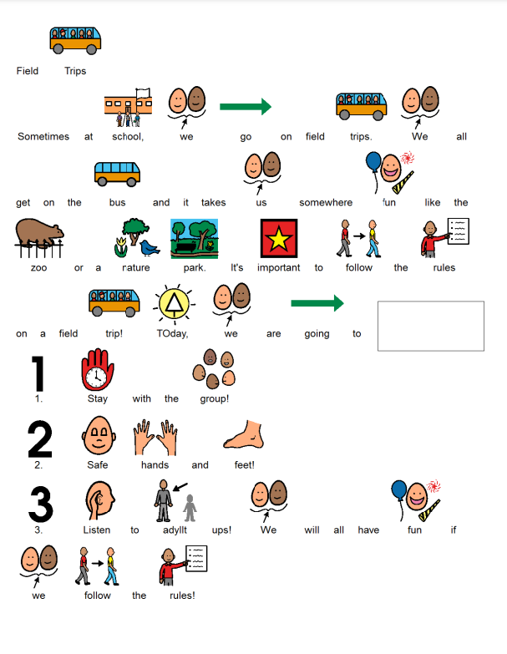
June 2nd
Oaks Park

