Some Practical Unit Conversions:
The directions say to add 1.6 to 2 oz per 3 gallons which covers around 1,000 ft.²
How much pesticide concentrate to add to a 1.5-gallon tank to cover a 4,000-ft.² lawn?

IV drip conversion.

Batteries and lemons
Electrical cells can be produced using lemons or potatoes, along with electrolytes and electrodes of different metals. Investigate the factors affecting the voltage produced by such a cell.
Dependent: | The dependent variable voltage, lamp brightness?
Student might ask: | How does the spacing between electrodes affect the voltage?

Bicycle stopping
Investigate the motion of bikes, cars, or any objects skidding to a stop.
Dependent: | The dependent variable stopping distance,
Student might ask: | How does the total weight of the bike, initial velocity, relate to the stopping distance?

Big splash
Investigate the splash of water when a ball falls into a bucket of water.
Dependent: | The dependent variable is given, but only in a vague way. The student must define what a “splash” is. (height, volume, horizontal range, etc…)
Student might ask: | How does the drop height of a ball affect the range (as measured from the center of the bucket) of the water splashing out?

Bouncing ball
Investigate some physical property of a bouncing ball.
Dependent: | Time to stop bouncing, rebound height, ratio of height
Student might ask: | Is there a constant relationship between the drop height and the rebound height over a reasonable range of drop heights?

Bungee jumps
Bungee jumping can be simulated in the laboratory in different ways. Investigate one factor that affects the bungee jump.
Dependent: | Students must not only decide on the dependent and independent variables, but also define clearly what the variables are.
Student might ask: | How does the maximum rebound height of a bungee jump depend on the length of the elastic string?

Uncalibrated Knob on an Electric Drill and Strobe Light
Both have a numbered knob that is not in Hz. Investigate the marks on the knob. Calibrate the knob.
Dependent: | Frequency of motor or strobe
Student might ask: | How do changes in the knob position affect the frequency of the motor?

Cantilever deflection
Investigate one factor that affects the declination of a cantilever.
Dependent: | The dependent variable is given.
Student might ask: | How does the force at the end of a cantilever affect the declination?  How does length of overhang affect declination?

Cantilever oscillation
Using a hacksaw blade, investigate one factor that affects the oscillation frequency of the blade.
Dependent: | The dependent variable is given.
Student might ask: | How does the period of oscillation depend on the length of the blade?

Catapult
Investigate one variable affecting the launch and flight characteristics of a catapult.
Dependent: | The dependent variable is given.
Student might ask: | How is the range of a catapult’s projectile affected by the mass of the projectile object?

Ballistic Pendulum
Investigate the effects of collisions using pendulums
Dependent: | Somehow measure the effects of a collision between two objects hung on adjacent pendulums. (impulse, crumple zone, v_{f}, rebound angle)
Student might ask: | What is the relationship between the angle of release, mass of object,

Craters
In the laboratory, a ball can be dropped into a box of sand or modeling clay. Investigate the formation of craters.
Dependent: | Students must define all the variables and look for a relationship.
Student might ask: | What is the relationship between the depth of a crater and the drop height of a ball?

Dominoes
Investigate the domino effect with a set of dominoes.
Dependent: | Students must define all the variables and look for a relationship.
Student might ask: | What is the relationship between spacing of consecutive dominoes and the effective speed of the domino effect?

Drinking fountain
Investigate one factor affecting the projection of water from a rubber tube/nozzle connected to a weed poison sprayer, hose, etc…
Dependent: | Nozzle velocity m/s, flow rate ml/s, range or height of water jet
Student might ask: | What is the relationship between the # of pumps and nozzle velocity?  What is the relationship between water range and nozzle area (need nozzles)
Extension: | What is the relationship between the number of pumps and the pressure?’  What is the relationship between the water level (or air volume) and nozzle velocity with set pumps?

Electric motor
Investigate one factor that affects the efficiency of a small electric motor.
Dependent: | The dependent variable is efficiency = power out/power in
Student might ask: | What is the relationship between the weight or voltage on an electric hoist and its efficiency?

Electrical play dough
Investigate an electrical property of a chunk of play dough.
Dependent: | Students must define all the variables and look for a relationship.
Student might ask: | What is the relationship between the shape of play dough and its resistance?

Electromagnetic strength
Build an electromagnet and investigate its magnetic characteristics.
Dependent: | The dependent variable could be strength.
Student might ask: | What is the relationship between the current in the electromagnet and the number of paper clips that the electromagnet can hold?

Evaporation
Investigate factors affecting evaporation.
Dependent: | The dependent variable is given.
Student might ask: | What is the relationship between the surface area of a container of water and the rate of evaporation?

Fluid resistance
Fluid resistance can be studied in the laboratory with different fluids and small balls falling through them. Investigate one factor affecting the motion of a ball bearing falling through a liquid.
Dependent: | The dependent variable could be motion a characteristic.
Student might ask: | What is the relationship between terminal speed and the temperature of a given fluid?  What is the relationship between terminal speed and dimples on surface.

Margarine tub sliding
Investigate one factor affecting motion of a weighted margarine tub when it is sliding along a runway.
Dependent: | The dependent variable is distance sliding, time sliding, final speed if on ramp.
Student might ask: | What is the relationship between the mass of the tub and the distance travelled?

Paper helicopter
Construct a paper helicopter by cutting paper into a “T” shape, folding over (in opposite ways) the hat (blades) of the “T”, and adding a paper clip. Investigate some property of the toy helicopter.
Dependent: | Students must define all the variables and look for a relationship.
Student might ask: | What is the relationship between the helicopter blade area and the time it takes to drop a given height?

Pool depth
Submerge balls of various sizes to the bottom of a swimming pool. Investigate any relationship between some physical property of the ball and how it rises back to the surface.
Dependent: | The dependent variable could be time to rise, or path linearity/serpentine path.
Student might ask: | What is the relationship between the size of a ball and the time it takes to rise up to the surface?

Springs
Investigate the oscillation of a spring.
Dependent: | The dependent variable can be period, max velocity, time to decay
Student might ask: | How does the period of oscillation relate to the number of coils?  How does period relate to mass hanging or amplitude?  How does max velocity relate to amplitude?

Book drop volume/energy
Investigate the energy released when a dropped book/object strikes the floor
Dependent: | The dependent variable could be destructive effect or volume of impact or momentum transfer.
Student might ask: | How does the volume of sound of collision relate to the height of book drop?  Or volume relate to time of collision.

Impulse vs. Vertical Leap
Investigate the effect of impulse upon vertical leap
Dependent: | The dependent variable vertical leap or hang time
Student might ask: | How does the total impulse relate to the height of jump?

Elevator Acceleration Curve with Force Plate
Investigate the acceleration curve of an elevator
Dependent: | Acceleration, constant speed, deceleration
Student might ask: | How does the motion of an elevator change during a trip?

Centripetal Force / Friction vs. acceleration
Investigate the effect of friction upon centripetal acceleration
Dependent: | The dependent variable centripetal acceleration
Student might ask: | How does the friction between tires and road affect centripetal acceleration?

Bottle Drain Rate
Investigate the water draining out of a bottle.
Dependent: | Drain rate
Student might ask: | Hole size, hole location, pour angle, vent hole size, drain hole shape

Molding Clay Crumple Zone
Investigate collisions with molding clay, dropping steel balls into clay, dropping clay balls etc…
Dependent: | The dependent variable “crumple zone” of molding clay bumper
Student might ask: | How does the flattening of a sphere of clay relate to velocity?  Can I determine velocity from crumple zone of clay bumper?

Design a Potential Energy Storage/Transformer: catapult, ramp launcher, gravity assist electric generator

Design a car that can climb the steepest slope.

Design a car that can sprint fastest.

Conductive paper
Investigate some electrical property of conducting paper.
Dependent: | Students must define all the variables and look for a relationship.
Student might ask: | What is the relationship between the effective resistance of a square of conducting paper and the paper’s total surface area?

Example of a Design experiment

Teacher prompt: “Investigate the domino effect using a set of dominoes”
The teacher shows the students the domino effect by lining up a number of dominoes and then lightly pushing the first one, so producing the domino chain reaction. Students have studied mechanics and waves. This is an open-ended investigation where the students must decide on both the dependent and independent variables.
Students would satisfy aspect 1 of design (defining the problem and selecting variables) if they:
- State a clear research question, for example, “How does the separation between a fixed number of dominoes affect the time it takes for all the dominoes to fall?”
- Identify the relevant variables correctly, for example, the dependent variable as the pulse speed or time to fall, the independent variable as the separation of the dominoes, and the control variables as the number of dominoes and the surface upon which the dominoes rest.
- Discuss possible applications of the results to help solve “real-life” problems.
Under aspect 2 of design (controlling variables) students would earn a “complete” if they addressed the following.
- The method of starting the domino motion: for example, a student might use a small inclined plane of fixed length and roll a ball down the incline in order to hit the first domino with the same impulse for the various trials of the experiment.
- A method for timing: for example, a student might use two photo-gate timers, one at the start and one at the end of the domino chain. They could use video analysis. They could also just use a stopwatch.
- Standardization: students would explain how they would keep the domino chain in a straight line.
- Details of controlling the independent variable: there should be discussion as to how the distance between the dominoes is altered and how the distance between consecutive dominoes is made the same for each trial.
- A list of materials: this would include a box of dominoes, photo-gate timers or stopwatch, a ramp and small ball for the incline, a meter stick to keep the domino chain at a constant 2.00 m length, and a 30 cm rule for measuring domino separation.
Under aspect 3 of design (developing a method for collection of data) students would earn a “complete” if they addressed the following.
- Repeated measurements: students would realize that repeated measurements for the same domino separation are required. An average time would then be calculated.
- Scope and limit: students would realize that the minimum separation of the dominoes is when they are touching, face to face, that is, zero separation. Students would also realize that there is a maximum separation that is more or less equal to the height of a domino. Students would ensure that a suitable range of values is chosen between these limits.
- Changing the number of dominoes one at a time allows for ample data within the allowed range.
Data Collection and Processing: Aspect 1 Recording raw data

To earn a complete in Aspect 1 students need to

Voltage V  + .01 V | Current I  + 0.3 mA
1.00 | 0.9
2.00 | 2.1
3.00 | 2.8
4.00 | 4.1
5.00 | 5.0
6.00 | 5.9
7.00 | 7.0
- present raw data in a clear and comprehensible way
- consistent sig figs
- include the name of the quantities
- symbols and units
- estimated uncertainty for each raw data quantity.

Voltage I | Current  Amps
1 | 0.9
2 | 2.1
3 | 2.8
4 | 4.1
5 | 5
6 | 5.9
7 | 7
For a partial, students need to present raw data in an appropriate manner bur there may be some mistakes or omissions.
- Clear presentation
- Inconstant sig figs
- Some missing symbols and units
- No uncertainty recorded

A student may earn not at all if no raw data is recorded or if essential information is missing.
Voltage and Current Data
1 @ 0.9, 2 @ 2.1, 3 @ 2.8, 4 @ 4.1, 5 @ 5, 6 @ 5.9, 7 @ 7

DCP Aspect 2: Processing raw data
This aspect is usually thought of as the calculations section. Often raw data is multiplied of divided, added or subtracted from other values of constants. When this is done, errors and uncertainties should be propagated.
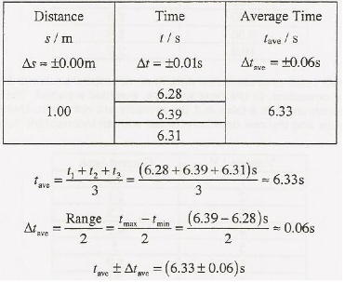
In this example the student finds the average of three trial measurements of time. She earns a complete.
- Correctly calculates and properly rounds average
- Correct propagation of uncertainty in average
- Correctly rounds average to three sig figs
- Correct rounds uncertainty to the hundredths place

In the next step the student calculates the square of the average time determined above. Again she has earned a complete.
- Correctly propagates uncertainty into percent then back into absolute terms.
- Correctly rounds squared time to three sig figs.
- Correctly rounds uncertainty to last decimal place of squared time.
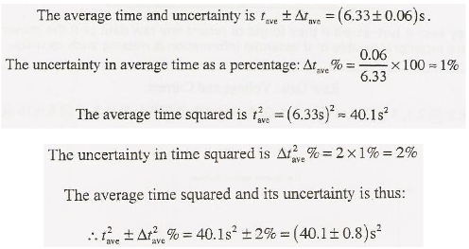

However there are cases when the raw data is appropriate for graphing and for establishing a conclusion from the graph. In such cases processing will be understood as the transfer of data to an appropriate graph, constructing a best-fit line and determining slope. The processing of uncertainty consists in correctly constructing relevant uncertainty bars on the graph and correctly determining max and min slopes.

DCP Aspect 3: Presenting processed data

A student constructs a graph of current against voltage. He uses the slope of the graph and uncertainties in the current to establish resistance and its uncertainty. This example earns a complete.

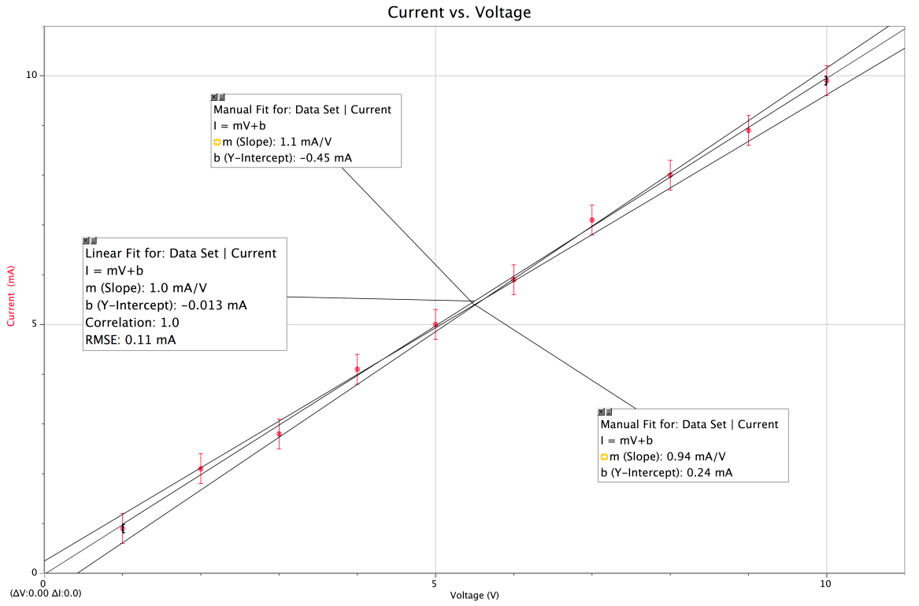

In this graph slope = I/V, but resistance = V/I so resistance = 1/m.
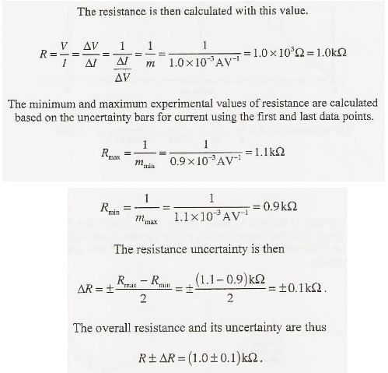

Conclusion and Evaluation: Aspect 1 Concluding
Conclusions that are supported by the data are acceptable even if they appear to contradict accepted theories. However, the conclusion must take into account the severity of systematic or random uncertainties. When determining an already known value of a physical quantity, evaluate the confidence in their result by comparing their experimental value (and uncertainty range) to the textbook value.

For example after constructing the graph of current against voltage, the student makes a reasonable and justified interpretation of the data earning a complete.

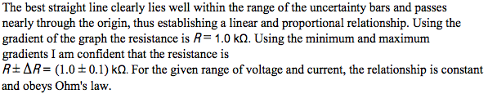

For a partial the student does not provide justification for the quality of the conclusion. Although the quality of data is deemed good, the student doesn’t use the error bars as justification only the slope.

CE Aspect 2: Evaluating procedures (Review Design: Aspects 1 & 2)
Students must not only list the weaknesses but must also estimate how significant the weaknesses are.
- Comment on the precision of data (closely grouped trials show small random error)
- Evaluate the accuracy of data (close to known value shows small systematic error)
- Students should specifically look at the processes, use of equipment, and management of time.
There was no attempt to control for differences in size and/or mass of individual dominoes. It was assumed all dominoes were identical. Since separation was measured from the front of one to the back of the next, differences in thickness were not accounted for. Also, the ability of one domino to knock over the next depends on the relative masses that were not measured.

CE Aspect 3: Improving the Investigation
Improvements should be based on the limitations identified in Aspect 2.
- Modifications should address the precision, accuracy and reproducibility of results.
- Students should suggest specifically how to reduce random error.
- Students should suggest specifically how to remove systematic error.
- It is not sufficient to state that better equipment should be used.
Measuring distance from center-to-center would control for differences in thickness. If significant differences in mass exist, dominoes with similar masses should be selected.

